**Final report**

**Business Analytics   
Course: Project Big data (X_400645).**

**Students:**

Yannick Hogebrug – 2626424 - y.r.hogebrug@student.vu.nl  
Jesse Schouten – 2621562 - [j7.schouten@student.vu.nl](mailto:j7.schouten@student.vu.nl)

Submission date: 30-06-2018



# Introduction

This study was focused on the data analysis of a bedtime procrastination study. Bedtime procrastination is related to sleep problems, to which severe outcomes including memory and health problems have been related by several studies (Kroese et al., 2014). By analyzing personal sleeping data, as well as poststudy questionnaire data filled out by the participant, the following questions were attempted to be answered:

* *Can bedtime procrastination be significantly influenced by experiment?*
* *How well can bedtime procrastination be predicted?*

These questions will be answered during this report. Furthermore, a few visualizations will provide extra insight into the data.

# Data description and exploration

After merging the two datafiles, the final data has multiple variables for each participant in the study. 5 participants didn’t fill in the questionnaire, so they were excluded from the data in the merged dataframe. The available variables are shown below including a short explanation if necessary:

- *Gender:* Male (=1) or female (=2)

- *Age:*

- *Chronotype:* 7 point scale if you are more a morning person (1) or an evening person (7)

- *Bp_scale:* Bed procrastination scale; the higher, the more procrastination

- *Motivation:* Going to bed on time each night (1 = not motivated, 7 = very motivated)

- *Daytime_sleepiness:* 4-point scale from 0-3; 8 questions, values summed

- *Self_reported_effectiveness:* do you feel more rested since the intervention (range 0-7)

- *Group:* Control- (0) or experimental group (1)

- Delay_*nights:* Number of nights a participant delayed their bedtime (range 0-12)

- *Delay_time:* Mean time in seconds a participant delayed their bedtime

- *Sleep_time:* The mean bedtime in seconds

One of the targets of this research is to predict the variable ´delay_time’, which will be the answer on our second research question.

**Because procrastination is defined as: “voluntary delay of an intended course of action despite expecting to be worse off for the delay”.**

|  |  |  |  |  |  |  |
| --- | --- | --- | --- | --- | --- | --- |
|  | **count** | **mean** | **standard deviation** | **median** | **min** | **max** |
| **gender** | 42 | 1,5714 | 0,4949 | 2 | 1 | 2 |
| **age** | 42 | 31,7381 | 12,1500 | 27 | 18 | 61 |
| **chronotype** | 42 | 4,9762 | 1,8450 | 5 | 1 | 7 |
| **bp_scale** | 42 | 5,0690 | 0,9051 | 5.165 | 2,67 | 6,67 |
| **motivation** | 42 | 4,4524 | 1,1170 | 5 | 1 | 6 |
| **daytime_sleepiness** | 42 | 16,0476 | 3,8480 | 16 | 8 | 26 |
| **self_reported_effectiveness** | 42 | 2,6190 | 1,3619 | 2 | 1 | 6 |
| **group** | 42 | 0,4524 | 0,4977 | 0 | 0 | 1 |
| **delay_nights** | 42 | 7,2143 | 3,2699 | 8 | 0 | 12 |
| **delay_time** | 38 | 2354,6842 | 1438,2945 | 1974 | 0 | 5482 |
| **sleep_time** | 38 | 28822,3158 | 2848,8786 | 29190 | 21929 | 34644 |

To get an impression of all variables, we calculated some descriptive statistics, which are shown in Table 1.

Table : Descriptive statistics of the variables in the dataset

Table 1 shows all appropriate measures to introduce about the variables in the dataset. The count stands out as this is not the same for every variable. The cause of this is that some variables have empty cells for the variables ‘delay_time’ and ‘sleep_time’. For the analysis of the variable with an empty cell, it was decided to remove the corresponding row. So, for some tests more data might have been used then others, as it depends on the selected variables.

We see at least one strange value, which is the maximum of the daytime sleepiness. This variable is measured on a 4 point scale from 0 to 3, containing 8 questions. This means it could be at most 24. Further investigation turned out there are two observations with a daytime sleepiness larger then 24. Despite this, we decided to include those variables in the analyses. Also, the maximum of age and the maximum of motivation seem to be relatively high compared to the mean and/or median, indicating there might be some outliers. In the remaining of this report we will show various visualizations to give more insight into the distribution and outliers.

Because the delay time is of importance is this research, we further investigated this variable with the help of a plot. In this research we also look for differences between the two groups of the study, namely the control and the experimental group. The only difference between the groups is the fact that for the experimental group, the lights automatically dim at the intended bedtime. Because of this, we expect to see less delay time for the experimental than for the control group. Figure 1 shows the distribution of the delay time for both the control as the experimental group.

Some difference is spotted, but it is not clear whether this is significant, but the lack of observations has to be kept in mind.

Figure : Delay time per participant group

# Data analysis

In order to check whether the experiment had significant differences on sleeping behavior, an analysis of the sleeptime and delay time variables was made by comparing both the experimental group and the control group.

|  |  |
| --- | --- |
|  | P-value |
| Delay nights | 0.7425 |
| Sleep time | 0.8838 |
| Delay time | 0.05367 |

Table 2: Results of Wilcoxon signed rank test for difference in groups

To determine which tests to use, we made QQ-plots of the data, which are shown in Figure 2. This shows almost no rough straight lines, maybe except the sleep time in the control group. This indicates we can’t assume normality for the statistical tests of the three variables, displayed in Table 2. The variables are not from the same location scale family as the **standard** normal distribution (University of Iowa, 2016). For this reason, the Wilcoxon rank sum test was used as this is a distribution free test. The Wilcoxon rank sum test has the following hypotheses:

* H0: F=G
* H1: F≠G

The p-values of the performed tests are shown in Table 2.

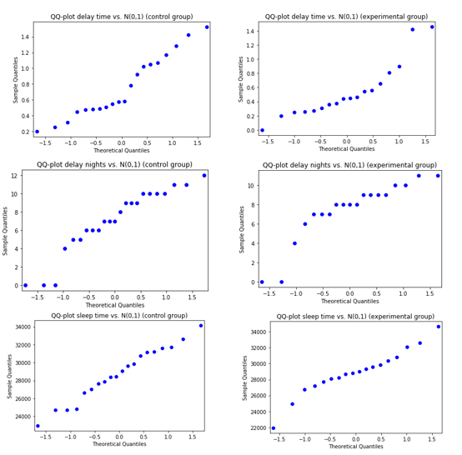

Figure 2: QQ-plots of delay time, delay nights & sleep time per group against N(0,1)

In order to get some insight in correlation between delay time and other variables, we made scatterplots, shown in Figure 3.

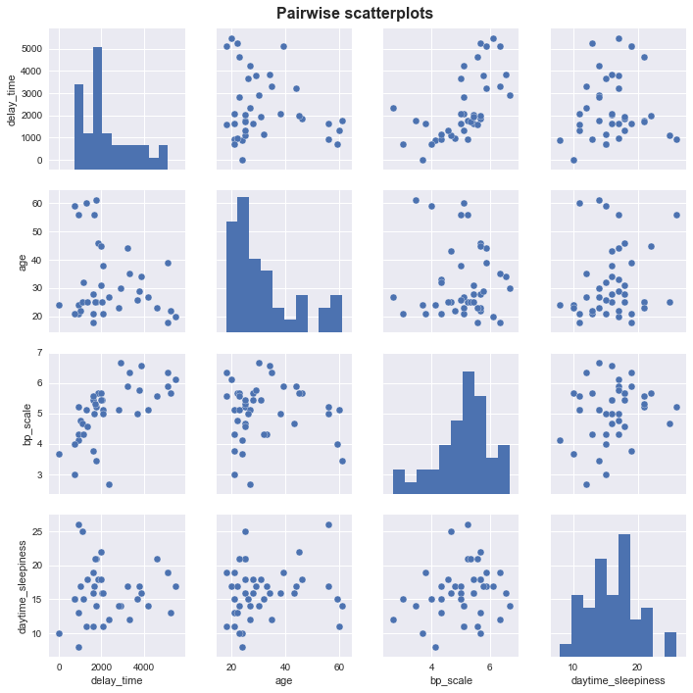

Figure 3: Pairwise plots of delay_time vs. three other variables

|  |  |
| --- | --- |
|  | **Correlation coefficient (r)** |
| Delay_time vs bp_scale (Pearson) | 0.6118 |
| Delay_time vs age (Kendall) | -0.02746 |
| Delay_time vs daytime_ sleepiness (Pearson) | 0.08328 |

Table 3: Correlation tests

Delay time and bp_scale seem to be correlated, because there could be drawn a straight line relatively easy through the cloud of points. As specified in Table 3, Kendall’s correlation coefficient and Pearson’s correlation coefficient were calculated between mean delay time and three other variables. The values of these coefficients are at least -1 and at most 1, indicating a perfect negative or positive correlation respectively. A value close to 0 indicates no correlation. It is noted Pearson just checks linear correlation, and Kendall’s checks more kinds of relationships (Statistics solutions, 2018). From Table 3 it can be noted the correlation coefficient of delay time and bp scale is the highest. For the other two variables, the values are pretty close to 0.

For the multiple regression model, information of prior analysis was used as much as possible to predict delay time. This resulted in a model with the following explanatory variables:

* ***bp_scale:*** a relative high correlation with delay time was found earlier.
* ***group:*** a possible statistical significance was found as a p-value just slightly higher than 0.05 can be seen in Table 2.
* ***chronotype:*** by context it would make sense evening people are more likely to delay bedtime.

Figure 4 provides some more insight in the relationship between delay time and chronotype and group.

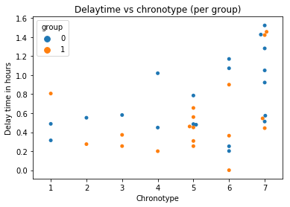

The fact that the blue points seem to lay relatively higher than the orange points in the plot stands out. Also, the delay time seems to be higher on average as the chronotype rises.

The final linear model including the three mentioned variable resulted in a R2-value of 0.475.

Figure 4: Plot of remaining variables in multiple linear regression model

# Discussion

During this report, we performed multiple tests on the data. The focus was on two research questions, which were mentioned in the introduction section.

The first question was about the differences between the two investigated groups to measure the influence of the experimental setup. We tested this with the help of the Wilcoxon rank-sum test. For all the tested variables, the null hypothesis was rejected. However, the p-value of the variable ‘delay-time’ was on the verge of rejecting by a significance level of 5%. Regarding the small number of observations, it is difficult to draw strong conclusions.

Besides, we looked for different variables if they were correlated with the delay time. The one that striked out was the variable ‘bp_scale’ with an correlation value of 0.61. Using the guide that Evans (1996) suggested for the absolute value of the correlation coefficient r, this correlation was considered to be strong. As shown in the data analysis part, the other variables were not highly correlated.

In the continuation of our study, we build a linear regression model to predict the delay time, so we could answer our second research question with the help of other variables. Here, we used the earlier obtained knowledge. We included the variables bp_scale, group and chronotype in the model. This resulted in a R2-value of 0.475, which means that 47,5% of the variance in the dependent variables (delay time) can be explained by the variance of the independent variables (bp_scale, group and chronotype). In contrast to the value of r, there is no specific ‘good’ or ‘bad’ value for R2, this really depends on the context (Nau, n.d.).

Although the R2-value did increase after adding the variables ‘group’ and ‘chronotype’, these variables didn’t seem to have significant effect on the model (p-values of respectively 0.108 and 0.064). For a linear model it is always preferred to include as less variables as possible, which will prevent problems like collinearity (Enders, n.d.). It seemed that only the variable bp_scale would be sufficient in the model.

Altogether, it is difficult to draw strong conclusions, based on this analysis. This is especially associated with the lack of observations. In another research, we advise to measure more participants or combine the outcome of that research with the one discussed in this report. Furthermore, we picked variables partly based on intuition. For another research, one could use for example the step-up strategy for determining the ‘best’ linear model.

Finally, more data of the participants could be collected. The sleep behavior of someone could also be influenced by the extent of effort that day or the smartphone use before sleeping (Scutti, 2017).

# Conclusion

We can draw the following conclusions from our research:

* There are no clear reasons to assume that bedtime procrastination could be significantly influenced by experiment. Conducted tests did not show any significance between the groups, although one of them was on the verge of rejecting (p-value of 0.053).
* With the help of a linear regression analysis, we concluded that bp_scale seemed to be sufficient for predicting the delay time. However, these model doesn’t seem really strong, regarding the small R2-value. It is difficult to draw a strong conclusion due to the lack of observations and because there is no real ‘good’ or ‘bad’ value for R2, though.

# References

Enders, F.B. (n.d.). *Collinearity.* Retrieved 27-06-2018, from <https://www.britannica.com/topic/collinearity-statistics>

Evans, J. D. (1996). *Straightforward statistics for the behavioral sciences.* Pacific Grove, CA: Brooks/Cole Publishing

Kroese, F. M., De Ridder, D. T., Evers, C., & Adriaanse, M. A. (2014). *Bedtime procrastination: introducing a new area of procrastination.*Frontiers in psychology, 5, 611.

Nau, R. (n.d.). *What’s a good value for R-squared?* Retrieved 26-06-2018, from <https://people.duke.edu/~rnau/rsquared.htm>

Scutti, S. (2017). *Your smartphone may be hurting your sleep.* Retrieved 27-06-2017, from <https://edition.cnn.com/2016/11/09/health/smartphones-harm-sleep/index.html>

Statistics solutions. (2018). *Correlation (Pearson, Kendall and Spearman),* from <http://www.statisticssolutions.com/correlation-pearson-kendall-spearman/>

University of Iowa. (2016). *QQ-plots and PP-plots, from* [*https://homepage.divms.uiowa.edu/~luke/classes/STAT4580/qqpp.html*](https://homepage.divms.uiowa.edu/~luke/classes/STAT4580/qqpp.html)